Ref. No: Date: 05.08.2023

Notice Regarding 4th Semester Programme SEC Paper Internal Exam
It is hereby notify all students of 4th semester programme that an assignment on paper CHEM-G-SEC-T-2A as internal exam must be submitted within 14/08/2023 in PDF format to departmental mail id (chemistry.pass@srikrishnacollegebagula.ac.in). Don’t submit any Xerox copy. No need to submit any hard copies right now but it will be taken in future if need.

Write on following topics :- (3+3+4 =10)
1. Preparation of magnesium bisilicate .
2. Chloromycetin or streptomycin .
3. Industrial preparation of ethyl alcohol .

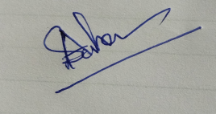
HOD
Department of Chemistry

